ATHOLL HOUSE OCTOBER NEWS ARTICLE

Residents at Atholl house had a spooktacular time at our Halloween entertainment afternoon on Tuesday 27th October with both relatives and residents dancing and singing along to Bruce Muellor our entertainer.
Staff also brought their children to the event and the residents was happy to see them in their lovely Halloween costumes.
All the residents had a great time even dressing in their own Halloween party hats. It was a fun filled afternoon enjoyed by all.

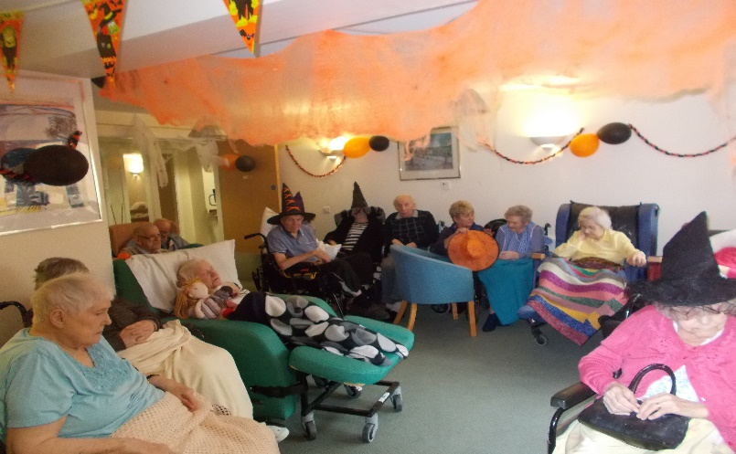
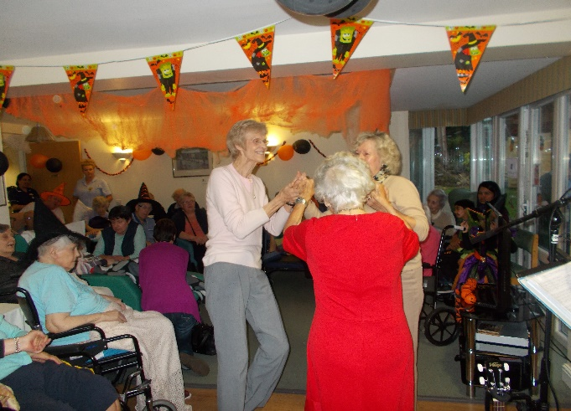
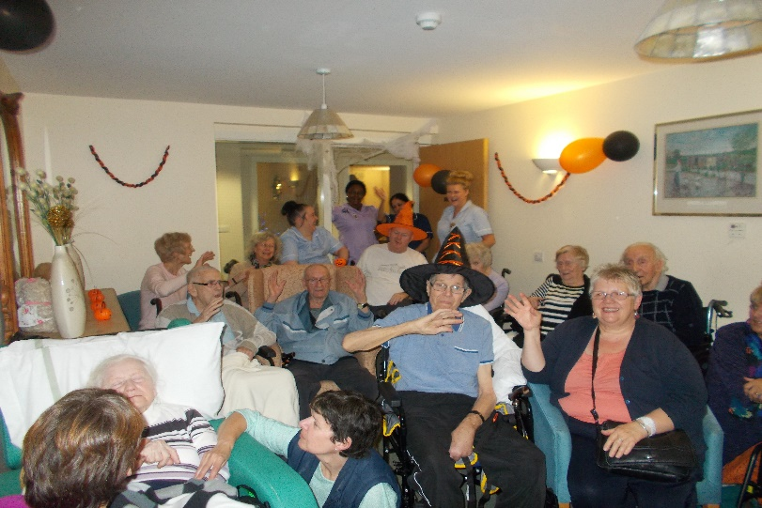
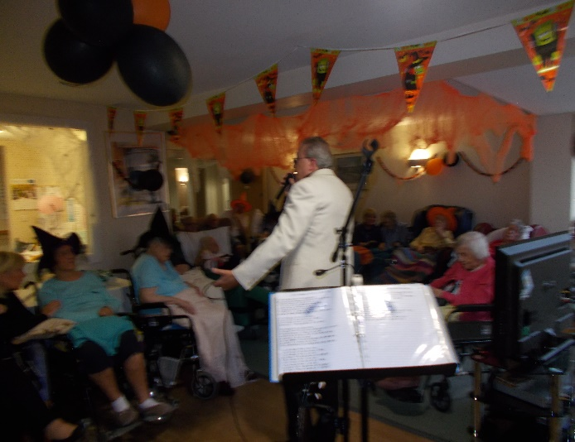

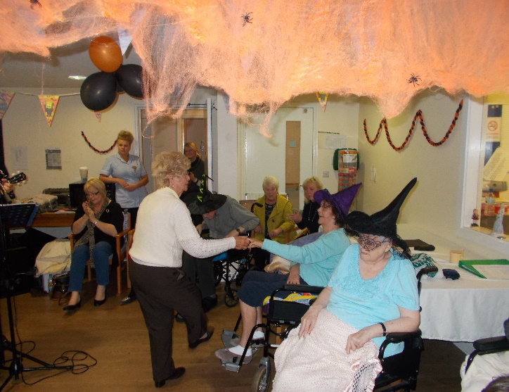
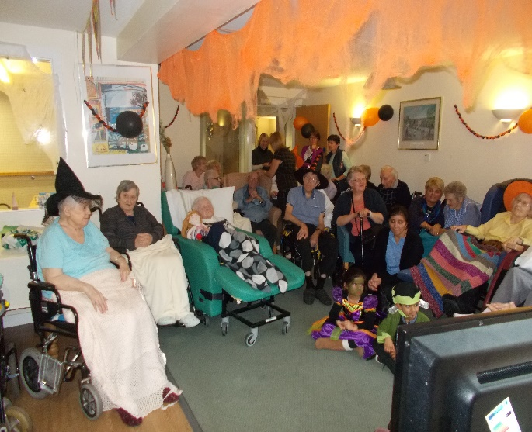

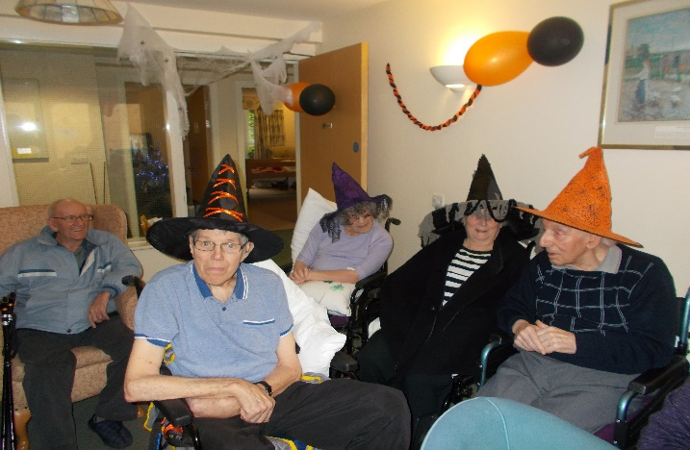
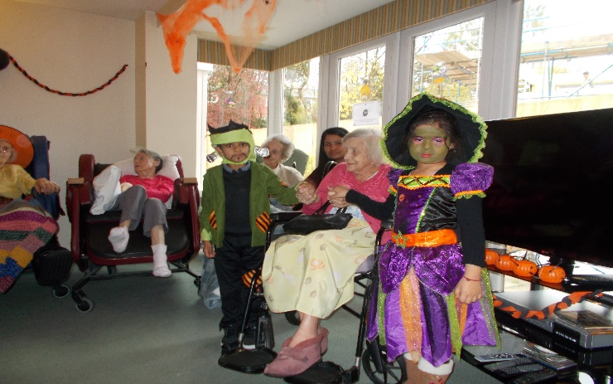

CHARITY FUNDRAISING EVENT
We would like to say a big thank you to all the staff, families and residents who took part and donate to our wear it pink day on 23rd of October.
We raised a total of £104 for the important cause which is now donated to the breast cancer fundraising charity.

